**LAB 3 MEI COMPARRISONS**

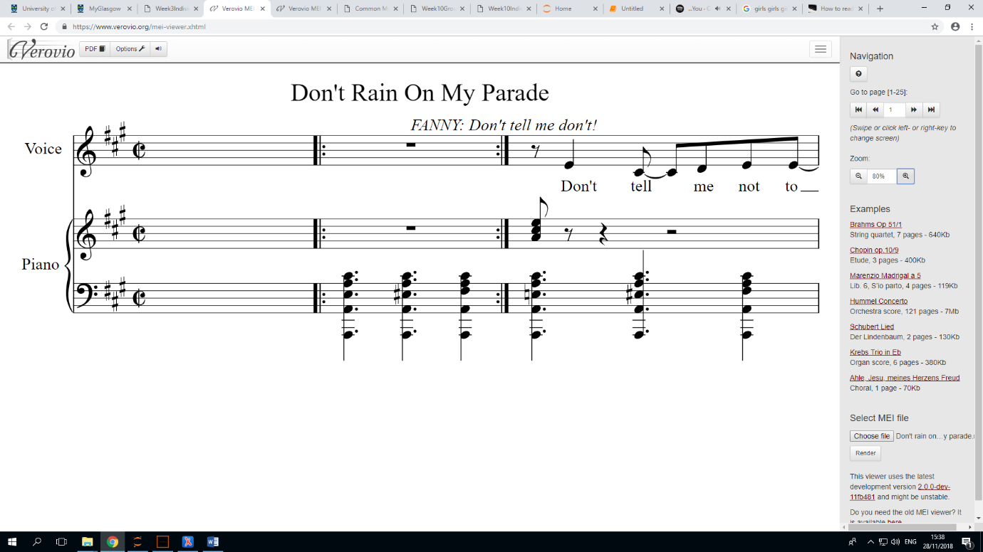ORIGINAL:

EDITED:

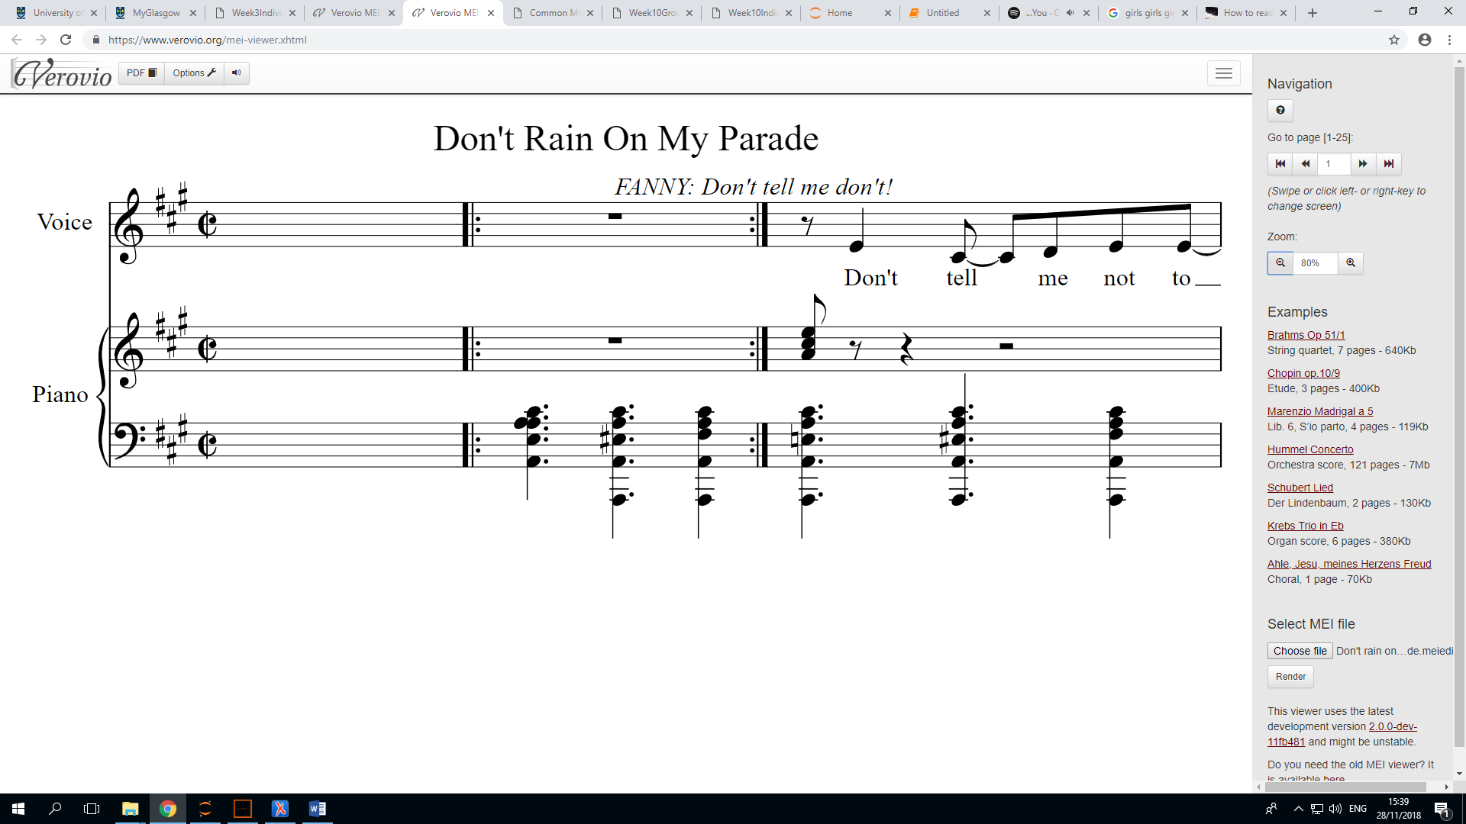

The note changes from an A to a C